**CSE 205 Review Session #2**

**Questions:** [**kvlopez1@asu.edu**](mailto:kvlopez1@asu.edu)

**GUI:**

**Layout Managers:**

* Flow Layout ( default one): organizes components from left to right, starting a new rows as necessary,
* Border Layout: Organizes components into five areas.

|  |  |  |
| --- | --- | --- |
|  | NORTH |  |
| WEST | CENTER | EAST |
|  | SOUTH |  |

* Grid Layout: Organizes components into a grid of rows and columns. When organizing components it works like a flow layout (Left to right)

|  |  |  |
| --- | --- | --- |
| **1** | **2** | **3** |
| **4** | **5** | **6** |

* Box Layout: Organizes components into a single row or single column

**3 steps to create a GUI program:**

1. Define and set up the components
2. Create a listener object by writing a class that implements a particular listener interface (ButtonListener, MouseListener etc.) Override the abstract method inside this listener interface, within the method body, define what happens in response to each event of interest.
3. Register the listener.

**Graphics Class:**

* Java.awt.*;
* Paint()
  1. The method is invoked automatically anytime there are graphic elements of the applet need to be painted on screen.
* Coordinate System in Java:
  1. (0, 0) is located in the upper left corner of screen.
  2. Anything (-x) and (-y) from the (0, 0) position will not show up on the screen.
* Methods in graphics class:
  1. Void drawRect(int x, int y, int width, int height)
     + To draw a square: int width and height must be the same.
  2. Void fillRect(int x, int y, int width, int height)
  3. Void drawOval(int x, int y, int width, int height)
     + A rectangle will be drawn first and the oval will be inside the rectangle measurements.
     + In order to draw a circle: int width and int height must be the same measurements.
  4. Void fillOval(int x, int y, int width, int height)
  5. Void drawLine(int x, int y, int x2, int y2)
  6. Void drawString( string x, int x, int y)
     + Int x and int y determine where the string will start.
  7. Void drawArc(int x, int y, int width, int height, int startAngle, int arcAngle)
     + A rectangle will be drawn first and then the angles will determine the arc
     + StartAngle and arcAngle go (+) counterclockwise, (-) clockwise.
  8. Void setColor( Color itsColor);
  9. Page.SetColor(Color.blue);
  10. Page.getColor();
* Page is an object from Graphics class.

Exercises:

**1. Complete the code to create the following applet:**

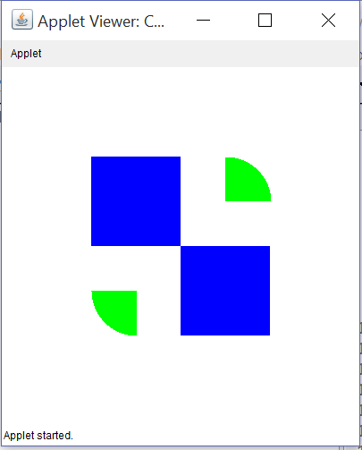

**import** java.awt.*;

**import** javax.swing.*;

**public** **class** CSE205ReviewSession **extends** JApplet

{

**public** **void** paint(Graphics page)

{

setSize(400,400);

page.setColor(Color.***blue***);

page.fillRect(200, 200, 100, 100);

page.fillRect(200, 200, -100, -100);

*other option: page.fillRect(100,100,100,100);

page.setColor(Color.***green***);

page.fillArc(200,100,100,100,90,-90);

*other option: page.fillArc(200,100,100,100,0,90);

page.fillArc(100, 200, 100, 100, 180, 90);

}

}

**2. Determine the output:**

**public** **static** **void** main(String[] args)

{

JTextField rstf = **new** JTextField("CSE205");

JLabel rsjl = **new** JLabel("ReviewSession");

rstf.setText("2" + rsjl.getText());

System.***out***.println(rsjl.getText() + rstf.getText());

}

Output:

ReviewSession2ReviewSession

**3. Sort the following integer arrays in INCREASING ORDER using the Selection Sort algorithm.**

A) 20,3,8,1,16,10,18,13

Steps:

1. 1,3,8,20,16,10,18,13
2. 1,3,8,20,16,10,18,13
3. 1,3,8,20,16,10,18,13
4. 1,3,8,10,16,20,18,13
5. 1,3,8,10,13,20,18,16
6. 1,3,8,10,13,16,18,20
7. 1,3,8,10,13,16,18,20

B) 15,18,18,10,5,4,2

Steps:

1. 2,18,18,10,5,4,15
2. 2,4,18,10,5,18,15
3. 2,4,5,10,18,18,15
4. 2,4,5,10,18,18,15
5. 2,4,5,10,15,18,18
6. 2,4,5,10,15,18,18

**4. Sorth the following integer array in INCREASING ORDER using the Insertion Sort algorithm.**

**A) 18,6,20,2,19,8,1,10**

Steps:

1. 6,18 | 20, 2 ,19,8,1,10
2. 6,18,20 | 2,19,8,1,10
3. 2,6,18,20 | 19,8,1,10
4. 2,6,18,19,20 | 8,1,10
5. 2,6,8,18,19,20 | 1,10
6. 1,2,6,8,18,19,20 | 10
7. 1,2,6,8,10,18,19,20

**B) 21,13,25,8,23,14,5,17**

Steps:

1) 13,21 | 25,8,12,14,5,17

2) 13,21,25 | 8,12,14,5,17

3) 8,13,21,25 | 12,14,5,17

4) 8,12,13,21,25 | 14,5,17

5) 8,12,13,14,21,25 | 5,17

6) 5,8,12,13,14,21,25 | 17

7) 5,8,12,13,14,17,21,25

**NOTES:**

Selection Sort running time: n^2

Scanner, FileReader & BufferedReader can all be used to read text from a file.

FileNotFound expection will happen if FileInputStream class tries to open a nonexistent file.

A file will be created if FileOutputStream class tries to open a nonexistent file.